LAB ASSIGNMENT 13.2
< AI ASSISTED CODING >
Program : B. Tech (CSE)
Specialization : AIML
Course Title : AI Assisted coding
Semester : III
Academic Session : 2025-2026
Name of Student : Md.heena
Enrollment No : 2403a54067
Batch No. : 01
Date : 28-10-2025

➢ Task Description #1 – Remove Repetition
Provide AI with the following redundant code and ask it to refactor
Python Code
def calculate_area(shape, x, y=0): if
shape == "rectangle": return x * y elif shape == "square":
return x * x elif shape
== "circle": return
3.14 * x * x
Expected Output
- Refactored version with dictionary-based dispatch or separate functions.
- Cleaner and modular design.
➢ Prompt:
Refactor the following Python function to eliminate repetitive conditional logic: def calculate_area(shape, x, y=0):
if shape ==
"rectangle": return x * y elif shape == "square": return x * x elif shape ==
"circle": return
3.14 * x * x
Use a cleaner, modular design—such as dictionary-based dispatch or separate functions for each shape—to improve readability and maintainability.
Code :
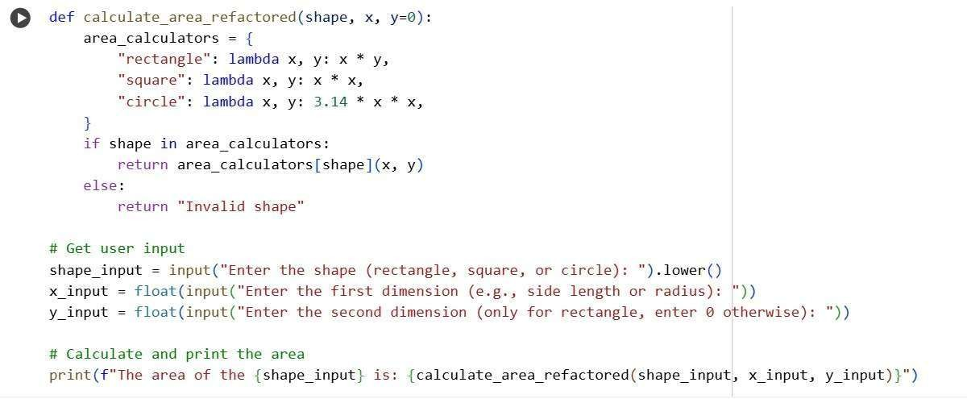
Output :
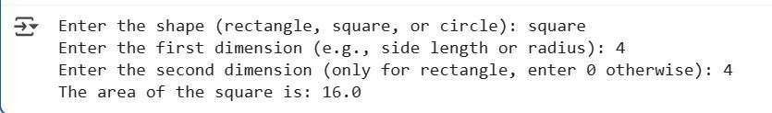
Explanation : calculate_area_refactored(shape, x, y=0) function:
Takes shape (a string representing the shape), x (the first dimension), and y (the second dimension, with a default value of 0) as input.
area_calculators is a dictionary that maps shape names to anonymous functions (lambdas) that calculate the area for each shape.
It checks if the provided shape exists as a key in the area_calculators dictionary.
If the shape is found, it calls the corresponding lambda function with x and y to calculate the area and returns the result. If the shape is not found, it returns "Invalid shape".
Observation : Refactored Logic: The code successfully refactors the area calculation logic by using a dictionary (area_calculators) to map shape names to their respective area calculation functions. This eliminates the need for multiple elif statements, making the code more readable and easier to maintain.
Modular Design: The use of lambda functions within the dictionary promotes a more modular design, where each shape's area calculation is self-contained.
User Input: The code includes user input prompts to make the area calculation interactive. It takes the shape, the first dimension, and an optional second dimension from the user.
Task Description #2 – Error Handling in Legacy Code
Legacy function without proper error handling Python Code def read_file(filename): f = open(filename, "r") data = f.read() f.close() return data
Expected Output:
AI refactors with with open() and try-except
Prompt:
Improve the following legacy Python function by adding proper error handling and using modern best practices:
def read_file(filename): f = open(filename, "r") data = f.read()
f.close() return data Refactor the code to use a with open() context manager and wrap the file operations in a try-except block to handle potential exceptions gracefully.
Code :
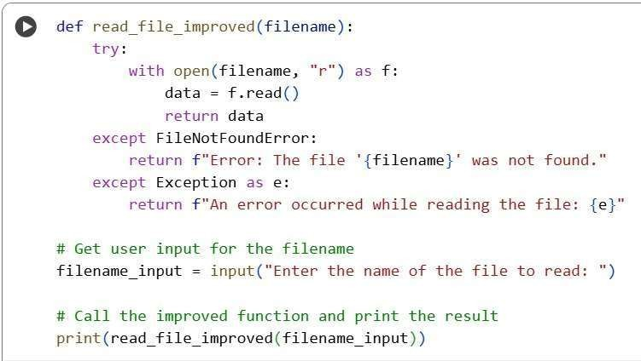
Output :
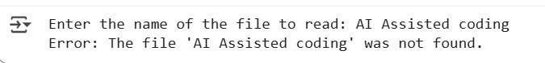
Explanation : read_file_improved(filename) function:
Takes filename (a string representing the name of the file to read) as input.
try...except block: This block is used for error handling. Code within the try block is executed, and if an error occurs, the code within the corresponding except block is executed.
with open(filename, "r") as f:: This is a with statement using a context manager. It opens the specified filename in read mode ("r"). The with statement ensures that the file is automatically closed even if errors occur, preventing resource leaks.
The opened file object is assigned to the variable f.
data = f.read(): Reads the entire content of the file into the data variable. return data: If the file is read successfully, the function returns the data.
Observation : Safe File Handling: It uses with open(...) to make sure the file is closed automatically, even if there's an error.
Handles Missing Files: It specifically checks if the file doesn't exist and tells you if it's not found.
Catches Other Errors: It also catches any other unexpected problems that might happen while reading the file.
➢ Task Description #3 – Complex Refactoring
Provide this legacy class to AI for readability and modularity improvements: Python Code class Student: def __init__(self, n, a, m1, m2, m3):
self.n = n self.a = a
self.m1 = m1 self.m2 = m2 self.m3 = m3 def details(self):
print("Name:", self.n, "Age:", self.a) def total(self): return self.m1+self.m2+self.m3
Expected Output:
- AI improves naming (name, age, marks).
- Adds docstrings.
- Improves print readability.
- Possibly uses sum(self.marks) if marks stored in a list
Prompt:
Refactor the following legacy Python class to enhance clarity and modularity:
class Student: def _init_(self, n, a, m1, m2, m3): self.n = n self.a = a self.m1 = m1 self.m2 = m2 self.m3 = m3 def details(self):
print("Name:", self.n, "Age:", self.a) def total(self):
return self.m1+self.m2+self.m3
Update the code with meaningful variable names, add docstrings, improve the output formatting in the details method, and consider storing marks in a list to simplify total calculation using sum().
Code :
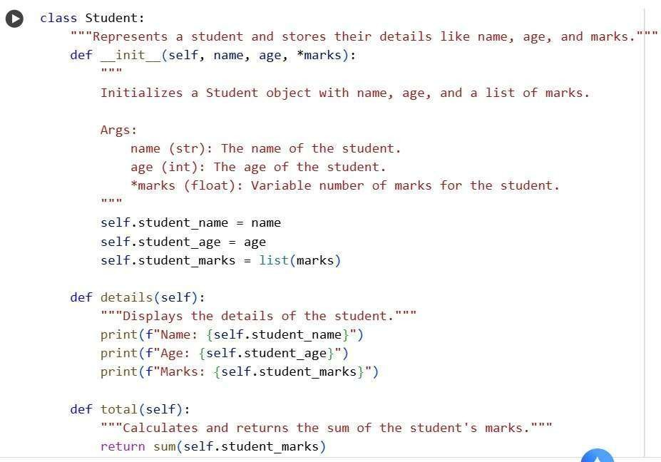
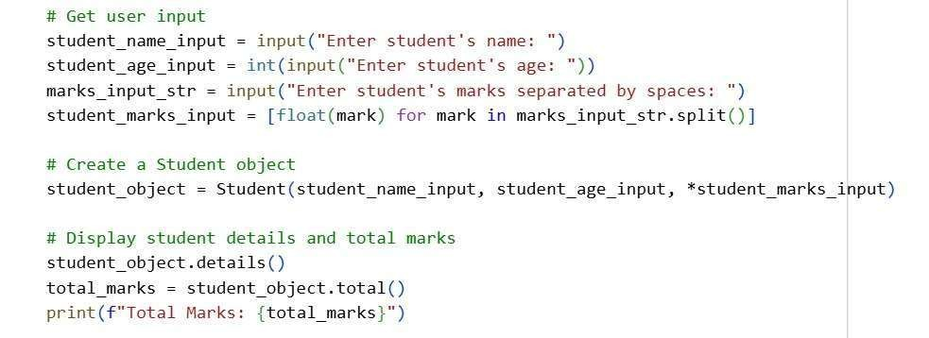
Output :
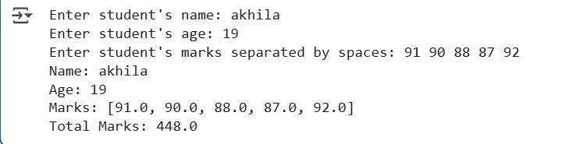
Explanation : Student Class Definition: class Student:: This line defines a class
named Student.
"""Represents a student and stores their details like name, age, and marks.""": This is a class docstring that explains the purpose of the Student class. _init_(self, name, age, *marks): This is the constructor method.
It takes self (a reference to the object itself), name, age, and *marks as arguments.
*marks allows you to pass a variable number of marks to the constructor, which are then collected into a tuple.
The docstring explains that this method calculates and returns the sum of the student's marks.
Observation : Improved Readability: The variable names like student_name, student_age, and student_marks are much clearer than the original n, a, m1, etc.
Better Organization: The use of docstrings for the class and methods makes the code's purpose and usage easy to understand.Flexible Mark Handling: Storing marks in a list (student_marks) and using *marks in the constructor allows for a variable number of marks, making the class more flexible.Simplified Total Calculation: Using sum() on the student_marks list is a clean and e icient way to calculate the total marks.Clear Output: The details() method uses f-strings for well-formatted and easy-to-read output.User Interaction: The code includes clear prompts for the user to enter student details.
➢ Task Description #4 – Ine icient Loop Refactoring
Task: Refactor this ine icient loop with AI help Python Code nums = [1,2,3,4,5,6,7,8,9,10]
squares = [] for i in nums:
squares.append(i * i)
Expected Output: AI suggested a list comprehension
Prompt:
Optimize the following Python loop for better performance and readability: nums = [1,2,3,4,5,6,7,8,9,10] squares = [] for i in nums:
squares.append(i * i)
Refactor the code using a more concise approach, such as a list comprehension, to generate the list of squared values.
Code :
Output :
Explanation : nums_input_str = input("Enter numbers separated by spaces: "): This line prompts the user to enter a series of numbers, separated by spaces, and stores the input as a single string in the variable nums_input_str.nums = [int(num) for num in nums_input_str.split()]: This is a list comprehension.
nums_input_str.split(): This splits the input string into a list of individual strings based on spaces. for num in ...: This iterates through each string in the list created by split(). int(num): This converts each string num into an integer.
[ ... ]: This creates a new list called nums containing the integer values.
squares = [i * i for i in nums]: This is another list comprehension, which is a more concise way to create a list of squared values. for i in nums: This iterates through each number i in the nums list. i * i: This calculates the square of the current number i.
[ ... ]: This creates a new list called squares containing the squared values.
Observation : Takes Numbers from User: It asks you to type in numbers, separated by spaces.
Smartly Squares Numbers: It quickly figures out the square of each number you enter using a neat Python trick called a "list comprehension".
Clean and Short: The way it squares the numbers is very short and easy to read compared to a longer loop.
Shows Original and Squared: It prints both the numbers you entered and their squared versions.

